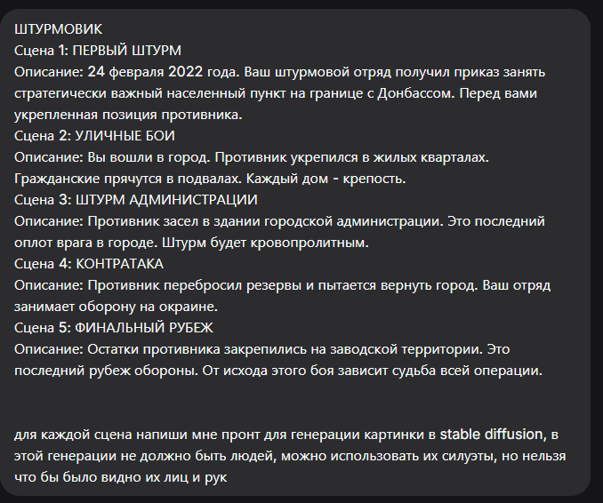

Конечно, вот промты для каждой сцены, созданные в соответствии с вашими требованиями (без детализации лиц и рук, только силуэты).

Сцена 1: ПЕРВЫЙ ШТУРМ
Промт:
masterpiece, best quality, 8k, photorealistic, war scene, 24 February 2022, dawn, strategic village on the border of Donbass. A fortified enemy position with trenches, sandbags, and barbed wire. In the foreground, the silhouettes of a Russian assault squad advancing through a smoky field. Burning vegetation in the distance, overcast sky. No people visible, only their silhouettes, no faces or hands detailed.
Negative Prompt:
deformed, blurry, bad anatomy, disfigured, poorly drawn face, mutation, mutated, extra limb, ugly, poorly drawn hands, missing limb, blurry, floating limbs, disconnected limbs, malformed hands, long neck, human face, detailed face, fingers

Сцена 2: УЛИЧНЫЕ БОИ
Промт:
masterpiece, best quality, 8k, photorealistic, urban warfare, residential district of a war-torn city. A street with heavily damaged apartment buildings, bullet holes in walls, shattered windows. The silhouettes of soldiers taking cover behind a burned-out car. Smoke and dust filling the air. No detailed people, only dark silhouettes, no faces or hands. Cinematic, grim atmosphere.
Negative Prompt:
deformed, blurry, bad anatomy, disfigured, poorly drawn face, mutation, mutated, extra limb, ugly, poorly drawn hands, missing limb, blurry, floating limbs, disconnected limbs, malformed hands, long neck, human face, detailed face, fingers, civilians

Сцена 3: ШТУРМ АДМИНИСТРАЦИИ
Промт:
masterpiece, best quality, 8k, photorealistic, storming a brutalist concrete administration building at night. The building is scarred by explosions and gunfire. The silhouettes of assault troops moving in through a breached wall, illuminated by muzzle flashes and the light of a burning vehicle outside. Heavy smoke, dynamic composition. No visible human features, only black silhouettes.
Negative Prompt:
deformed, blurry, bad anatomy, disfigured, poorly drawn face, mutation, mutated, extra limb, ugly, poorly drawn hands, missing limb, blurry, floating limbs, disconnected limbs, malformed hands, long neck, human face, detailed face, fingers, clear faces

Сцена 4: КОНТРАТАКА
Промт:
masterpiece, best quality, 8k, photorealistic, defense on the outskirts of a city. A makeshift defensive position made of rubble and sandbags at dusk. The silhouettes of soldiers manning a machine gun nest, facing an open field. In the distance, incoming artillery explosions light up the smoky horizon. No people details, only silhouettes against the fire.
Negative Prompt:
deformed, blurry, bad anatomy, disfigured, poorly drawn face, mutation, mutated, extra limb, ugly, poorly drawn hands, missing limb, blurry, floating limbs, disconnected limbs, malformed hands, long neck, human face, detailed face, fingers

Сцена 5: ФИНАЛЬНЫЙ РУБЕЖ
Промт:
masterpiece, best quality, 8k, photorealistic, final assault on an industrial plant territory. A sprawling, dystopian landscape of rusted factory halls, pipelines, and warehouses. The silhouettes of special forces moving through the industrial maze under a gloomy, overcast sky. Final enemy stronghold. No detailed humans, only dark silhouettes, no faces or hands visible.
Negative Prompt:
deformed, blurry, bad anatomy, disfigured, poorly drawn face, mutation, mutated, extra limb, ugly, poorly drawn hands, missing limb, blurry, floating limbs, disconnected limbs, malformed hands, long neck, human face, detailed face, fingers, happy

